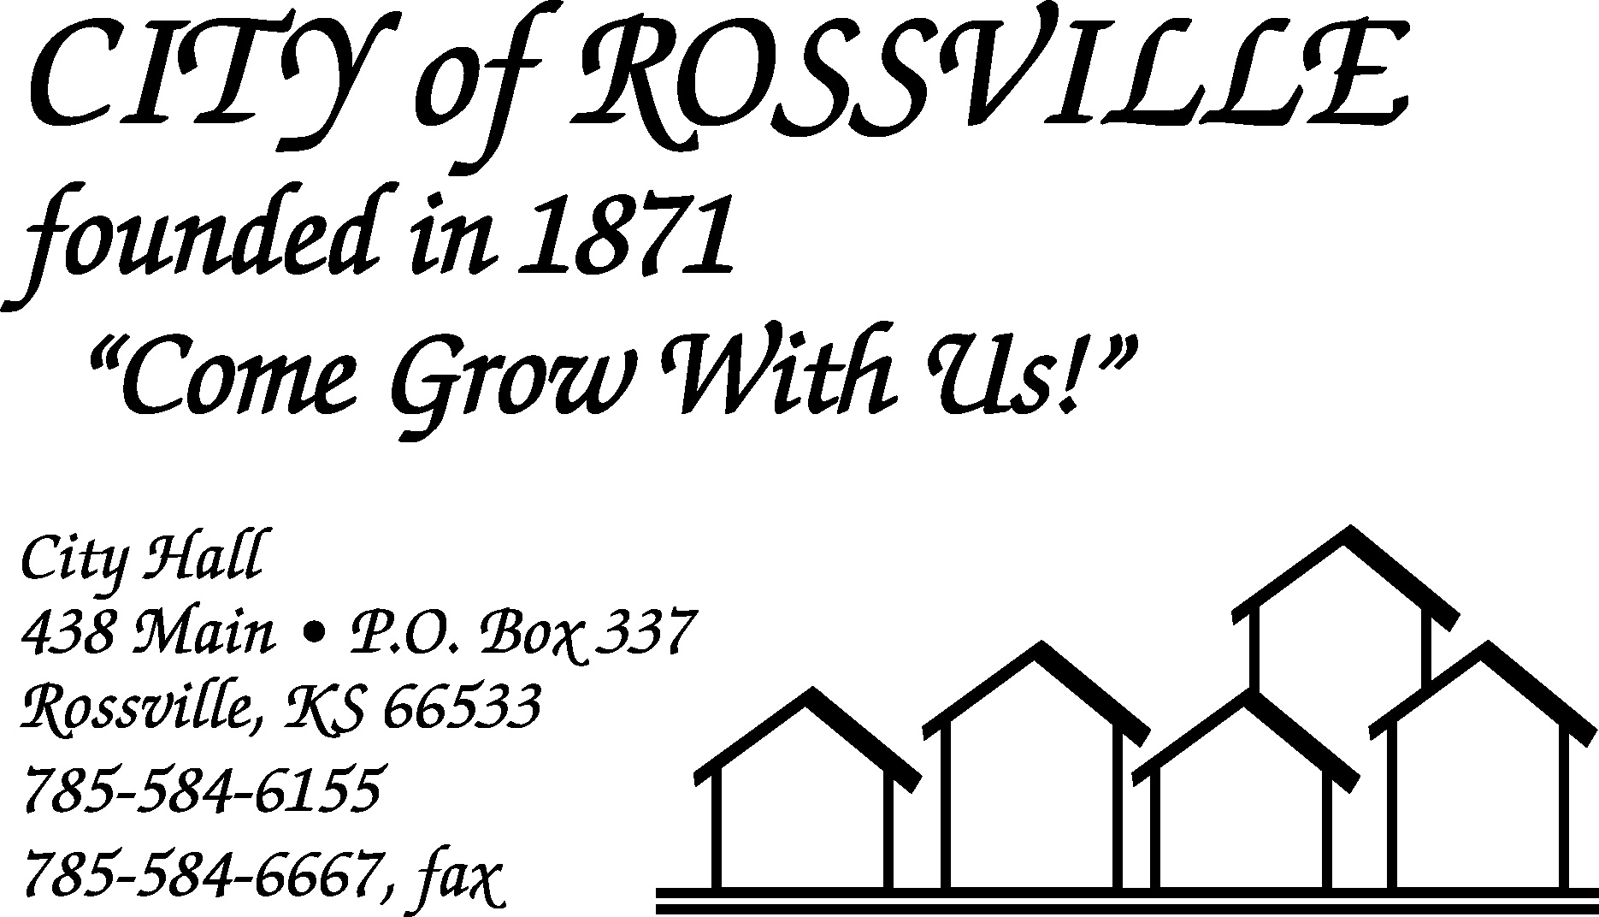

City Hall August 2, 2021

The Rossville City Council meeting was called to order on Monday, August 2, 2021 at 7:00 pm by Mayor Kenneth Wichman.

Council members present were Christi McKenzie, Dan Glotzbach, Toby McCullough and Trish Heim. James Meyer was absent.

Also present were Myron Leinwetter, Jason Connell, Andy Chance and Harry Hammer III.

Motion by Christi McKenzie to approve minutes of the July 19, 2021 meeting as written was seconded by Toby McCullough and carried.

The following bills were presented;
EFTPS-Fed WH $1,028.77 EFTPS-FICA $1,984.76
EMPower Retirement 380.00 Grace Hier 60.00
Kansas Payment Center 123.69 Kansas Withholding Tax 479.81
KP & F 1,050.40 KPERS 1,277.23
Alan Zlatnik 1,591.59 Tracey Taylor 840.38
Lisa Stum 1,162.44 Michael Kirk 1,164.38
Randall Anderson 797.68 Bowe Behymer 465.14
Trent Stanley 1,096.22 Jacob Akin 137.45
Jason Connell 1,040.42 Tina Dick 437.99
Kerry Dick 368.83 Harry Hammer III 236.07
Garick Topeka Materials Recycl 90.00 Ks. Retailers Sales Tax 778.27
U.S. Post Office 7.00 Amazon.com 135.81
Lonnie Q’s BBQ 720.00 Microsoft 8.00
Kenneth Wichman 523.49 Yahoo 23.99
Alan Streit 507.92 Alliance Insurance Corp 48.00
Aramark 221.85 Casey’s General Store 23.92
CNA Surety 200.00 Continental Research Corp 2,121.32
Core & Main LP 450.04 Krystal Brunin 500.00
Ks. Dept. of Health & Environment 18,201.56 Ks. Dept. of Revenue-Water Fee 452.91
MARC 179.09 Menards 118.01
CenturyLink 765.43 Evergy 1,748.40
Networks Plus 42.90 Kansas Gas Service 93.08
Saltus Technologies, LLC 1,856.00 Schulte Supply Inc. 89.66
Ks. State Treasurer-Court Fees 733.00 Universal Chemical LLC 612.62
Neptune User Conference 50.00 Fastdraws 72.54
TOTAL 47,098.06

Motion by Dan Glotzbach to pay bills as presented totaling $47,098.06 was seconded by Trish Heim and carried.

Motion by Dan Glotzbach to approve agenda as written was seconded by Trish Heim and carried.

Stanley Oyler arrived at 7:03pm.

Andy Chance was present to discuss notice of code violation that he received for vehicle at 517 Main Street. Following discussion council instructed Chance to continue to make repairs to vehicle while working with police department on getting time to complete work to bring vehicle in compliance with city code.

Ross Jory arrived at 7:14pm.

Myron Leinwetter was present to provide information on proposed plans for walking trails. Following discussion Leinwetter reported that they would form a committee to review and discuss items for lease agreement and bring a draft back to Council for review.

Alan Zlatnik arrived at 7:20pm.

Mayor reminded council that corn for the Tall Corn Festival corn eating contest would be delivered to councilmembers on Thursday and needs to be at the event on Friday at 6:30pm.

Utility Superintendent Alan Zlatnik reported that parts had been ordered for the crosswalk signal by the fire station as the battery was not staying charged.

Superintendent Zlatnik reported that Beyond Baseball had removed equipment and supplies from Campbell field with the exception of the deck and inquired about plans for deck during tall corn festival events. Council instructed Zlatnik to rope off deck due to concerns about safety.

Superintendent Zlatnik reported that the city limit signs on the North and South entrances to town had been removed and that electric service was available at both locations. Council noted that the signs on the East and West entrances looked good after the work completed by the utility department.

Police Chief Jason Connell reported that they were continuing with code enforcement and asked council if they had any concerns or issues for the upcoming Tall Corn Festival celebration. Council discussed with Chief Connell closing of the 400 block of Main Street for car show, changes to grade school student drop off location and talked to officer Hammer III regarding contact with KDOT regarding school zones and highway 24 crossings.

Council reviewed draft of 2022 budget and agreed to proceed with publication of notice of hearing.

Council reviewed current water rates. Following discussion, no action was taken.

Clerk reported that the city had received $85,259.11 in ARPA funding from the State. The other $85,259.11 was expected to be sent to the city in 2022.

Ordinance establishing and amending Chapter 1 of the Rossville Municipal code concerning contracted collection agency services to collect delinquent accounts and assess collection costs and FEES was presented. Motion by Toby McCullough to approve ordinance was seconded by Christi McKenzie and carried. Ordinance was assigned #832.

Motion by Dan Glotzbach to adjourn was seconded by Toby McCullough and carried. Meeting adjourned at 8:35pm.

City Clerk
Lisa M. Stum

